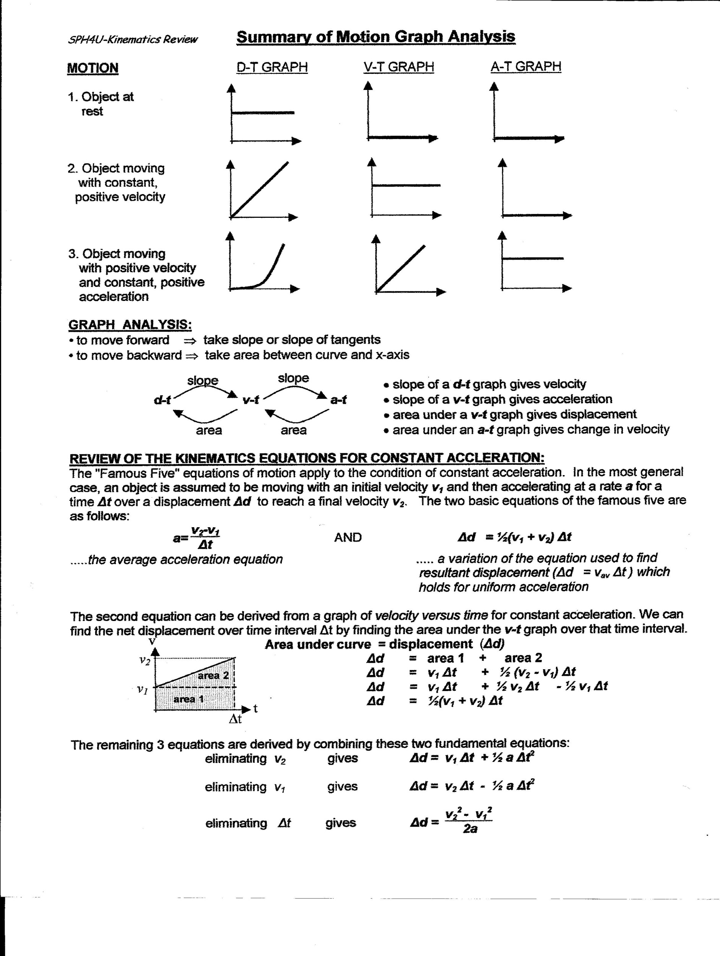

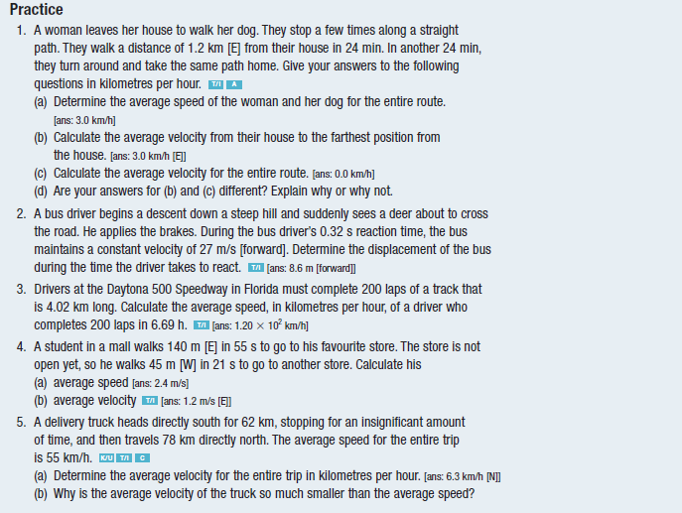
Nelson Textbook Questions Section 1.1 and 1.2 for 1-D Kinematics Review
Page 10, Practice 1,2,4,5,

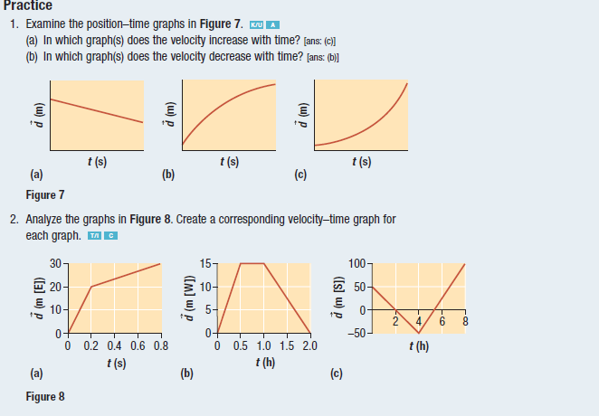
Page 13, Practice 1,2

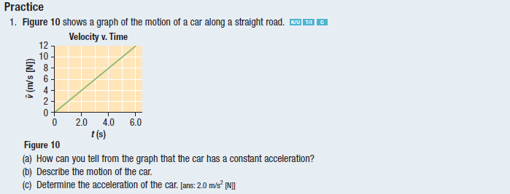
Page 15, Practice 1

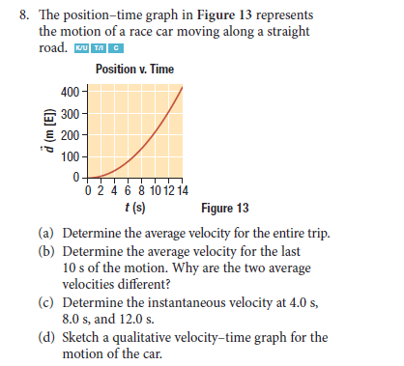
Page 16, Practice 8

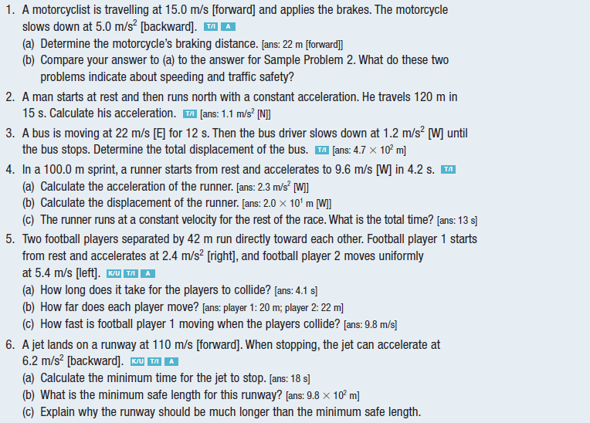
Page 19, Practice 1-6

Page 21, Question 6, 7
